DATN-2377- Advanced Analytical Tools and Methods
Lab Work 3 for Chapter 12
(Total 100 points)

Perform the following exercises in your Jupyter notebook.

Submission Guidelines:
- Ensure that you complete this lab work using a Jupyter Notebook.
- Once the lab work is finished, convert the file into HTML format.
- Lastly, upload the HTML file to D2L for submission.

Chapter 12:
Exercise 12-1 Another analysis of the polling data (100 points)
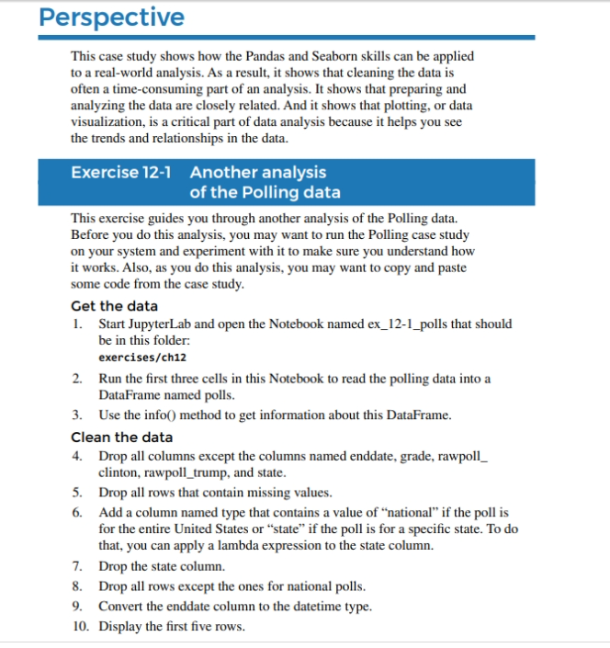
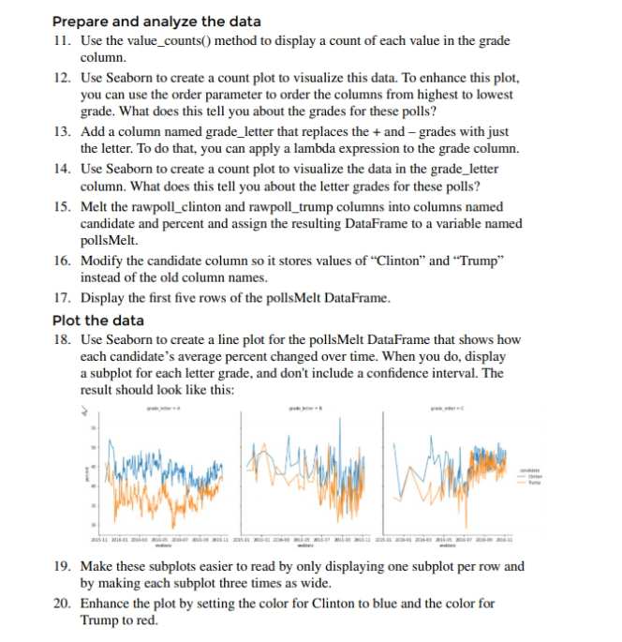

Lab work 3.
Project Name: Geographic Visualization of Wildfires
Description: This project involves creating geographic visualizations of wildfires in the United States using Python and geospatial data. It includes mapping wildfire locations, color-coding them based on the duration of the fire, and adjusting the size of data points to represent the acres burned. The project aims to provide insights into the geographical distribution and characteristics of wildfires in Alas

